**INDIVIDUAL ASSESSMENT**

NAME/ID: David Chen (z5117378) DEMONSTRATOR: Jacky Feng

Considering the energy breakdown for residential buildings below, what are the five most effective actions that you could take to reduce energy consumption and greenhouse gas emissions in your home? Consider two cases:

a) you are renting your home

b) you own your home.

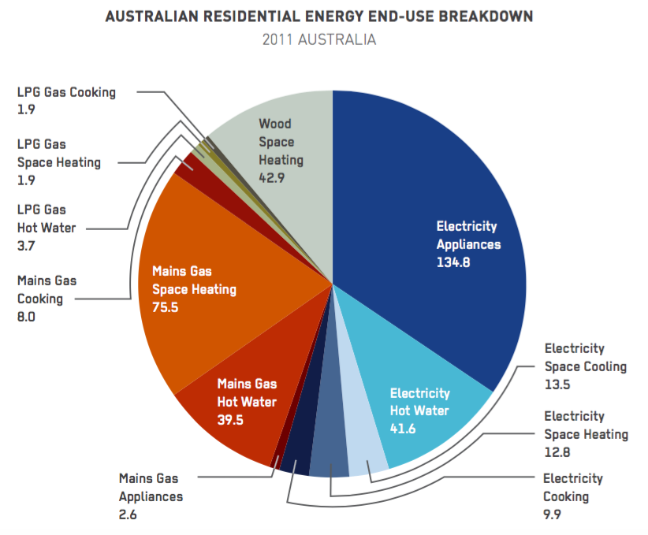  
BZE (2013) *Zero Carbon Australia Buildings Plan*. Beyond Zero Emissions, Melbourne Energy Institute,   
The University of Melbourne. <http://bze.org.au/publications>

|  |
| --- |
| 1. **Renting out home (Methods to reduce energy consumption and greenhouse gases)**   - Hot water: encourage the individual who is renting to decrease the length of showering time. By doing so, it decreases power usage and at the same time saves money  -Only use air-conditioning for an hour a day. Limit the amount of air-conditioning the individual can use in a day.  - Reduce gas usage: Limit gas usage the individual can use for a day and let the individual know that there is a limit on how much the can use.  - Automatic turn off lights: By installing automatic lights which turn off after a certain amount of time. Individuals who forget to turn off the light; the light would turn off by itself which is a good function for a renter.  - Encourage the individual to unplug and switch off standby electronics.   1. **For own Home (Methods to reduce energy consumption and greenhouse gases)**  * Reduce and recycle plastic: When buying products use eco-friendly products which are biodegradable and not harmful to the environment. * Solar panels: By installing solar panels, you are using a renewable resource (the sun) as a form of power. By doing so, you can reduce energy consumption and greenhouse gases overall. * Install insulators: By installing these, this would make the house warmer than usual and this slight change in temperature will consequently lead to a lowering in shower temperature and the less frequent use of air-conditioning during cold winters. * Water tank: Implementing a water tank reduce water usage and * Replace all the lights with compact florescent light (CFL). These bulbs last 10 times longer than regular light bulbs and also uses 2/3rd less power than regular light bulbs. |
|  |

**GROUP ASSESSMENT**

GROUP NAME/NUMBER: DEMONSTRATOR:

Thinking of your own project in this class and your EIA/LCA so far, what forms of sustainable energy could you include in your design to reduce its carbon footprint. List/discuss as many options as you can think of and why these would be an improvement over traditional methods of energy.

|  |
| --- |
|  |
|  |
|  |
|  |
|  |
|  |
|  |
|  |
|  |
|  |
|  |
|  |
|  |
|  |
|  |
|  |
|  |
|  |
|  |
|  |
|  |
|  |
|  |